SIMATS ENGINEERING
ASSESSMENT TOOL 1
COURSE CODE: CSA04 COURSE NAME: Operating Systems

COURSE OUTCOME COVERED
CO1: Apply the concepts of Operating System types, structures, and system calls to demonstrate their functions in various computing environments.

QUESTIONS: 5 Total Marks:100
Annexure A
SHORT ANSWER TEST
Code of Conduct:
I Ch.Akhil(192525250)(Name / Reg No) certify that this submission is my original work and that I have adhered to the guidelines specified for this assessment.
I understand that any violation of academic integrity rules will result in disciplinary action.
Signature of the student:Ch.akhil

Annexure A
Short Answer Test

Question 1 (5 Marks)
Suppose a modern Operating System supports multiple users and processes with shared resources like CPU, memory, and I/O devices.
- Classify different types of Operating Systems suitable for this scenario and justify your choice.
- Draw the structure of an Operating System showing how resources are managed.
- Write a sequence of system calls required to create and execute a new
process in such an environment. (BL2)

Question 2 (5 Marks)
Consider an Operating System managing multiple files and devices for concurrent users.
- Categorize system calls used for file and device management.
- Illustrate how the OS handles file operations using a layered structure diagram.
- Write a pseudo-code or C-based system call sequence to open, read, and
close a file. (BL3)

Question 3 (5 Marks)
Assume a real-time Operating System used in an embedded system controlling industrial machinery.
- Identify the type of OS and explain why it is suitable for real-time applications.
- Draw a diagram representing the interaction between hardware, kernel, and user processes.
- List and explain system calls required for process synchronization in this
system. (BL2)

Question 4 (5 Marks)
A distributed computing system consists of multiple interconnected computers sharing resources over a network.
- Classify the type of Operating System used and compare it with centralized OS.
- Draw the architecture of a distributed OS showing communication between nodes.
- Write the sequence of system calls involved in inter-process
communication (IPC). (BL3)

Question 5 (5 Marks)
Consider a scenario where an Operating System must manage process scheduling, memory allocation, and device communication efficiently.
- Explain the major functions of an OS in handling these tasks.
- Draw a block diagram representing OS components and their interactions.(c) Write system call examples for memory allocation and device

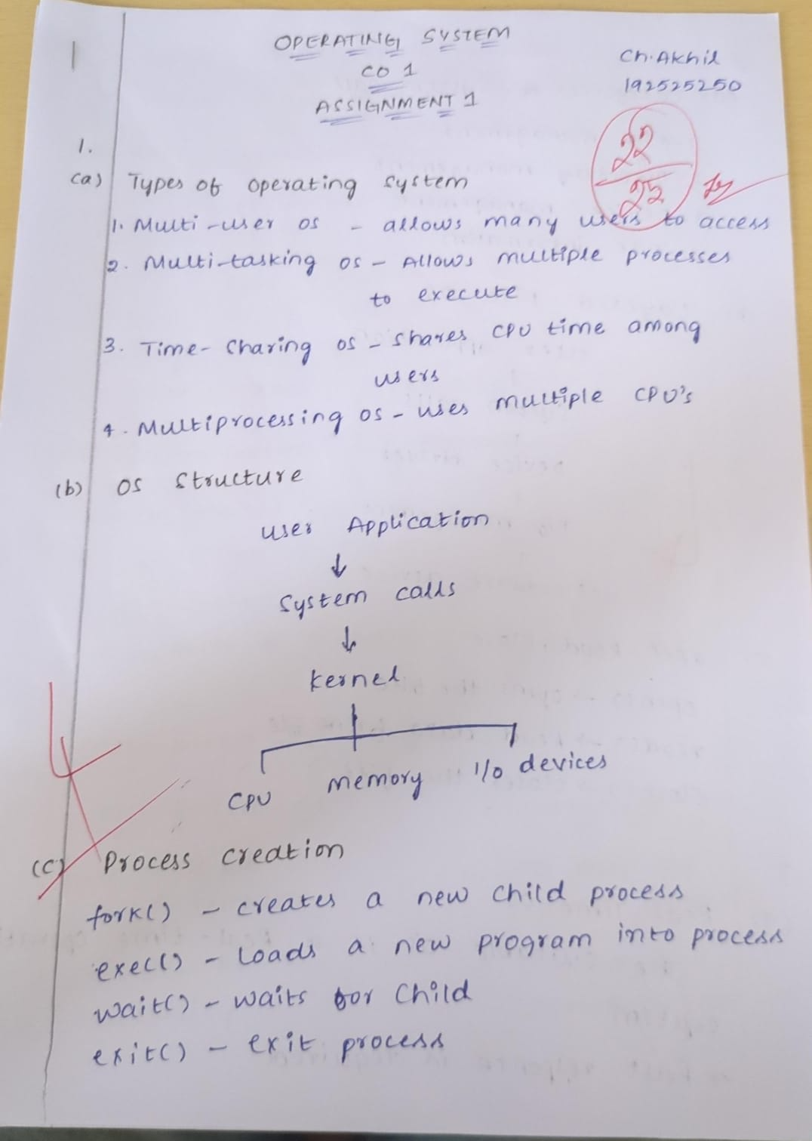

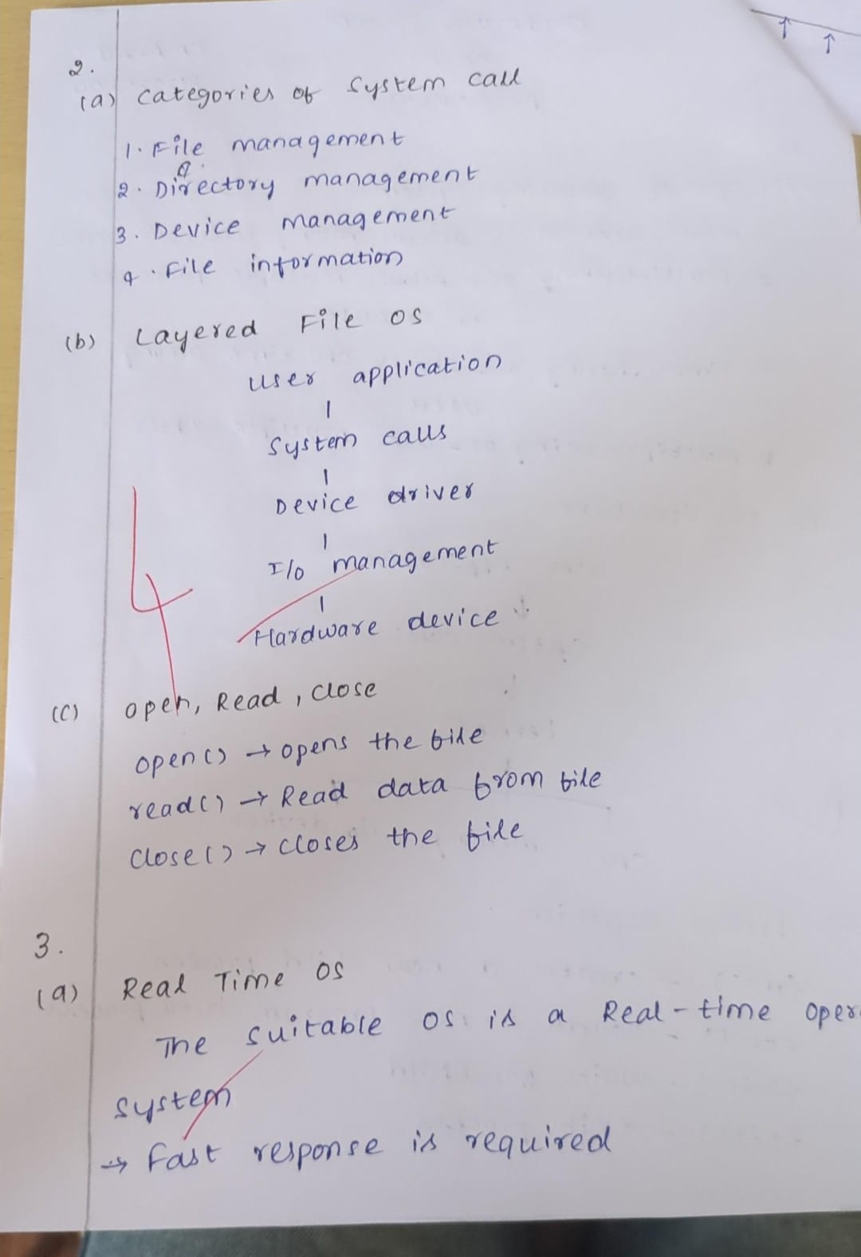

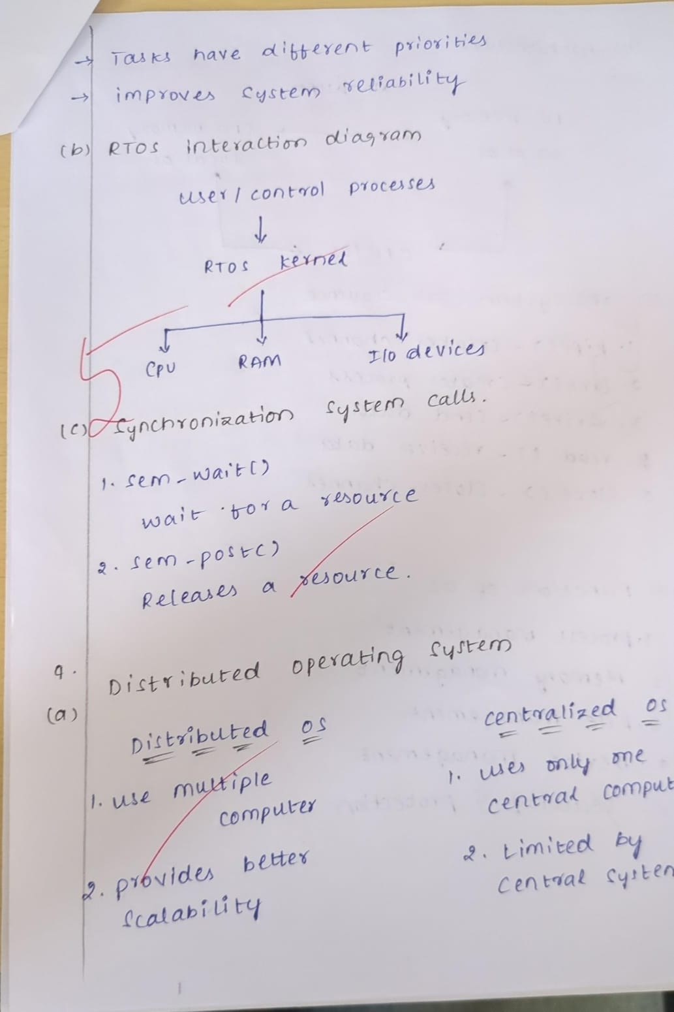

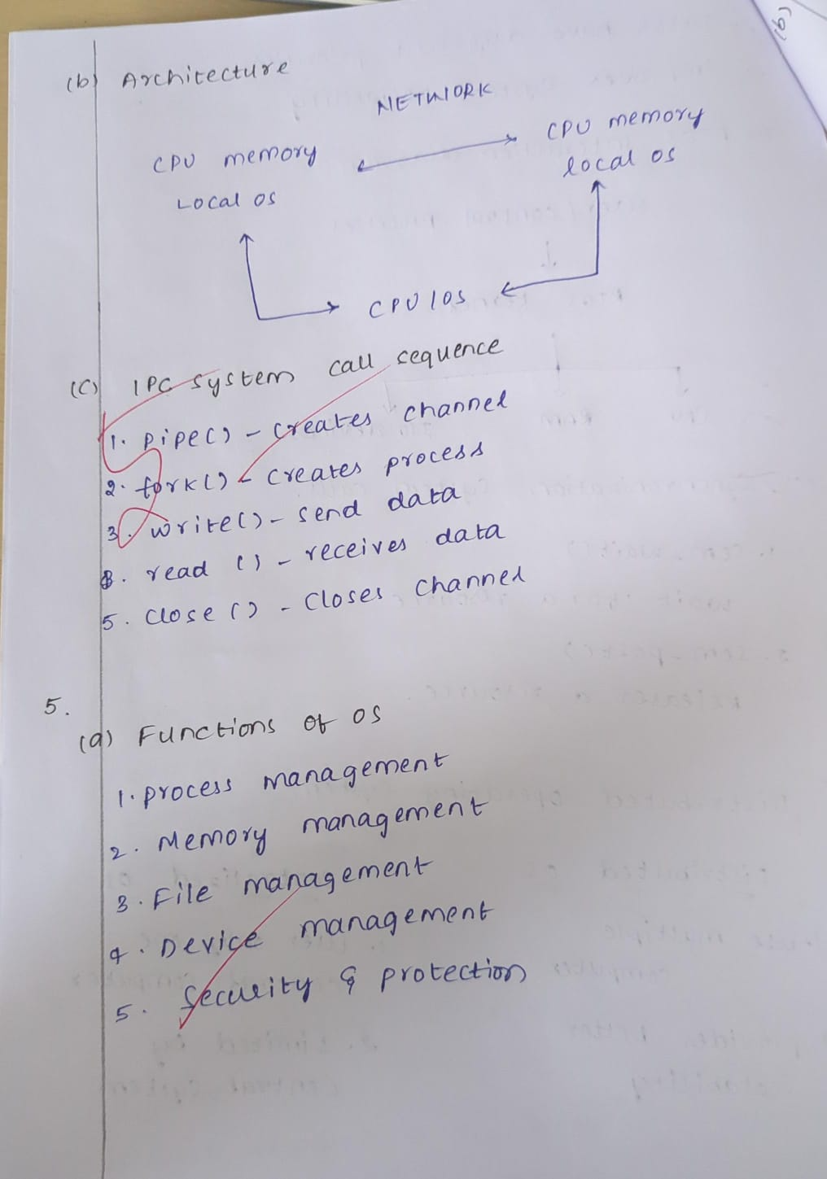

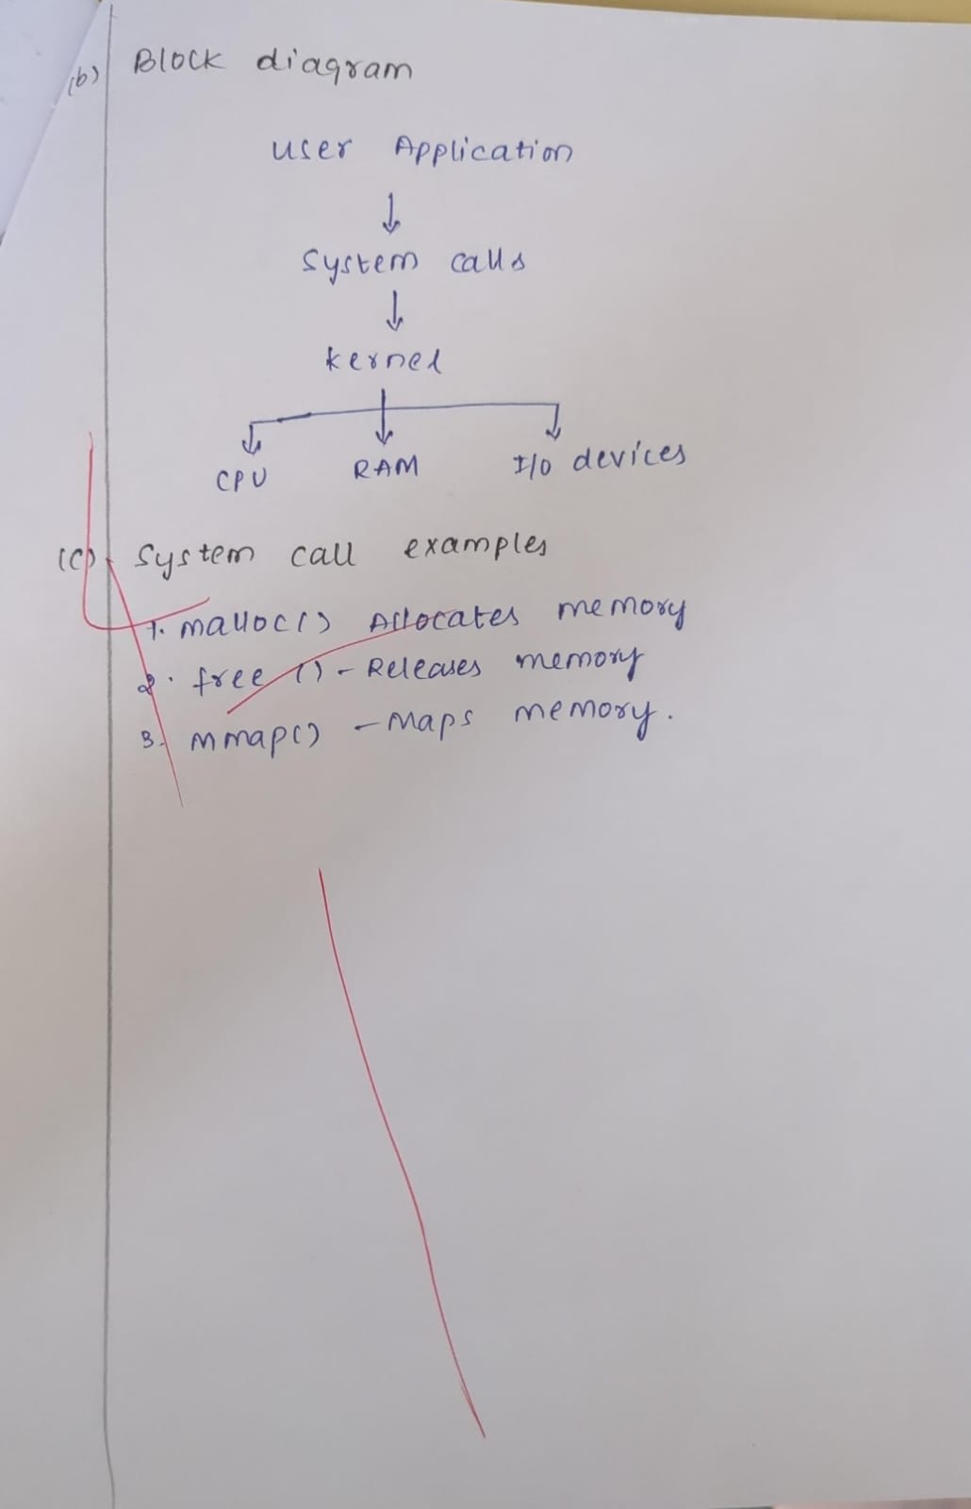

(BL3) RUBRICS FOR CALCULATION
Criteria | Weightage (Marks) | Level 4 – Exemplary (Full Marks) | Level 3 – Proficient | Level 2 –  Developing | Level 1 – Beginning
Conceptual  Understanding | 35 Marks | Demonstrates clear, complete, and in-depth understanding of OS concepts (types, structure, system calls) | Good understanding with minor gaps | Basic understanding with some misconceptions | Poor or incorrect understanding
Accuracy of Answers | 25 Marks | All answers are correct, precise, and  relevant | Mostly correct with minor errors | Partially correct with noticeable errors | Mostly incorrect or irrelevant
Application of  Knowledge | 15 Marks | Effectively applies concepts to scenarios/questions | Applies with minor mistakes | Limited or partial application | No meaningful application
Completeness of Response | 15 Marks | All parts of each  question are fully answered | Most parts covered with small omissions | Some parts missing | Incomplete answers
Clarity &  Presentation | 10 Marks | Clear, well-structured, and neatly presented answers | Understandable with minor issues | Somewhat  unclear or poorly structured | Difficult to understand

